Name:
Course:
Tutor:
Date:
Geocoding with ArcGIS
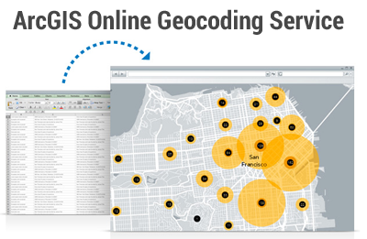
The Geocode above contains the historical Black colleges and universities in the United States. The areas that have been doted in the GIS platforms have been explained using the Geocodes above. These dotted values provided detailed explanation of the increased black colleges and Universities throughout the country. It is evident that in some of the states there are no colleges while in other states, there have been an increase in the distribution levels of these universities (Brown & Harder, 2016).

Works Cited
https://doc.arcgis.com/en/arcgis-online/reference/geocode.htm
Brown, C., & Harder, C. (2016). The ArcGIS imagery book: New view, new vision. Redlands: Esri Press.

